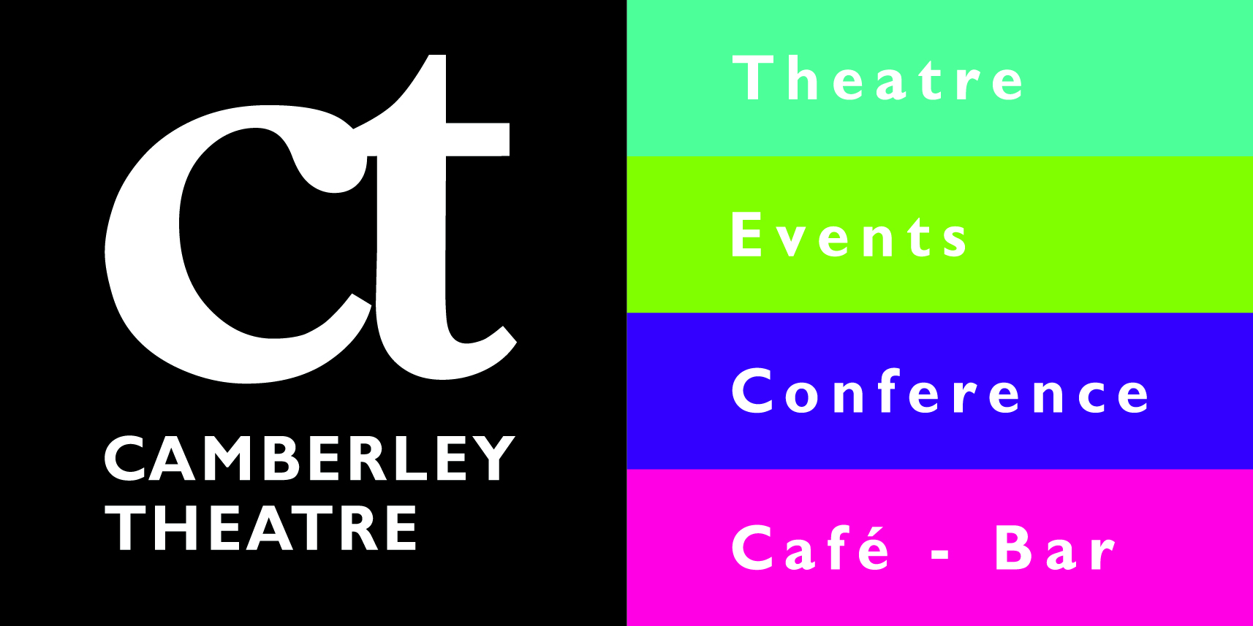
Camberley Theatre Kid’s Party Booking Form
Name
Address
Phone Number
Mobile Number
Email
Type of Party | Indoor Outdoor Crazy Character Party Sports Day Party  Neon Disco Party Wild Survivor Party Traditional Games Party  Theatre VIP Party
Select food option (for indoor parties only) | Cold food option Hot food option  (*sandwiches, crisps, (*chicken nuggets,  cocktail sausages) fish fingers, chips)
Specify Theme / Theatre show
Date of Party
Time of Party
Number of Children
Birthday Child’s Name and Age

All parties require a £50 non-refundable deposit to confirm the booking.
Invites are available free of charge from the Box Office.
Please be aware of the following conditions:
- Minimum of 15 children for all parties.
- All food except birthday cake is provided by Camberley Theatre and we do not allow self-catering.
- 2 adults must be present at all times. We request that parents who wish to stay during the activity wait in the bar at the Theatre, or the Function Room at Frimley Lodge Park where tea/coffee will be available for them.
- You are welcome to bring decorations and party bags; please leave these with your party host on arrival.
- All cancellations must be made 14 days before the party date. Any cancellations after this date will be charged for in full unless a suitable alternative date can be arranged.
Please email this form to zoe.stanton@surreyheath.gov.uk

